MongoDB in AWS

### **Create the EC2 Instance**

First install the AWS EC2 using the AWS link below (use AWS free educate account login)

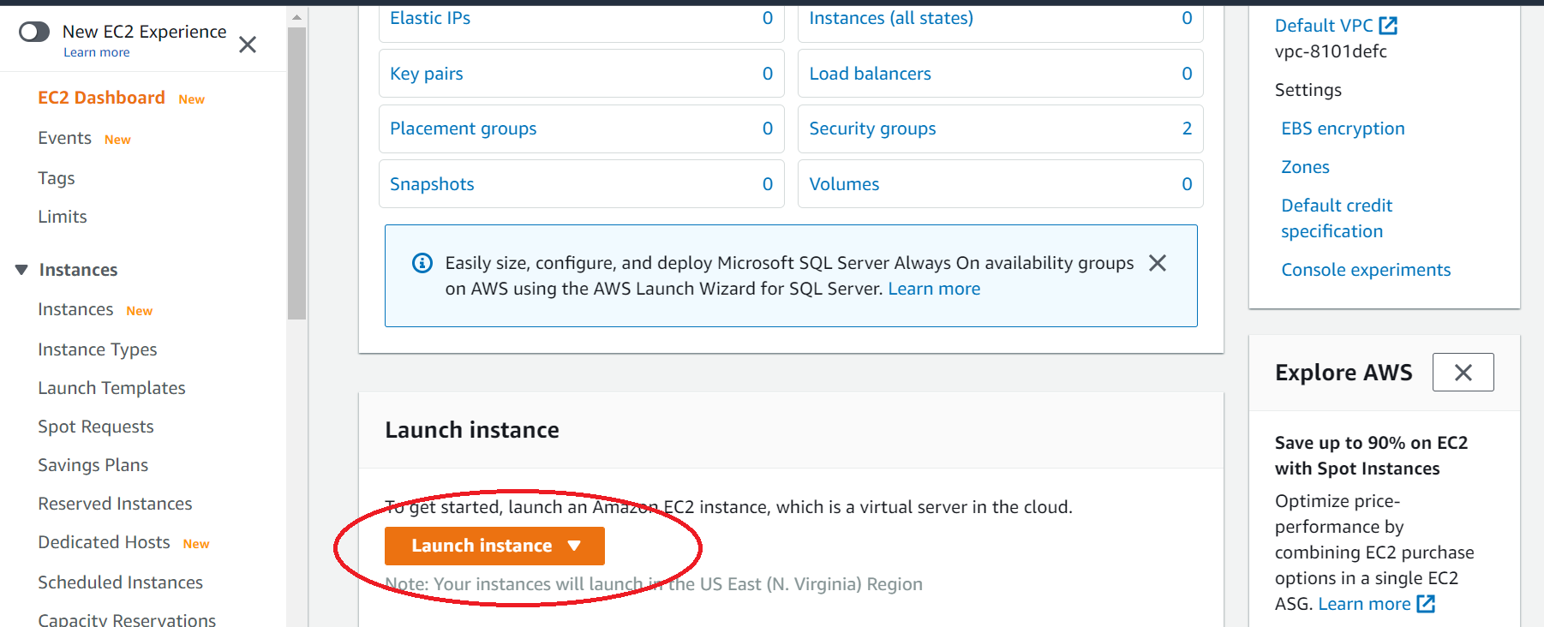

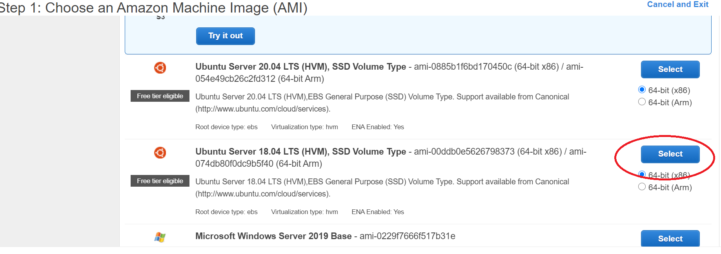

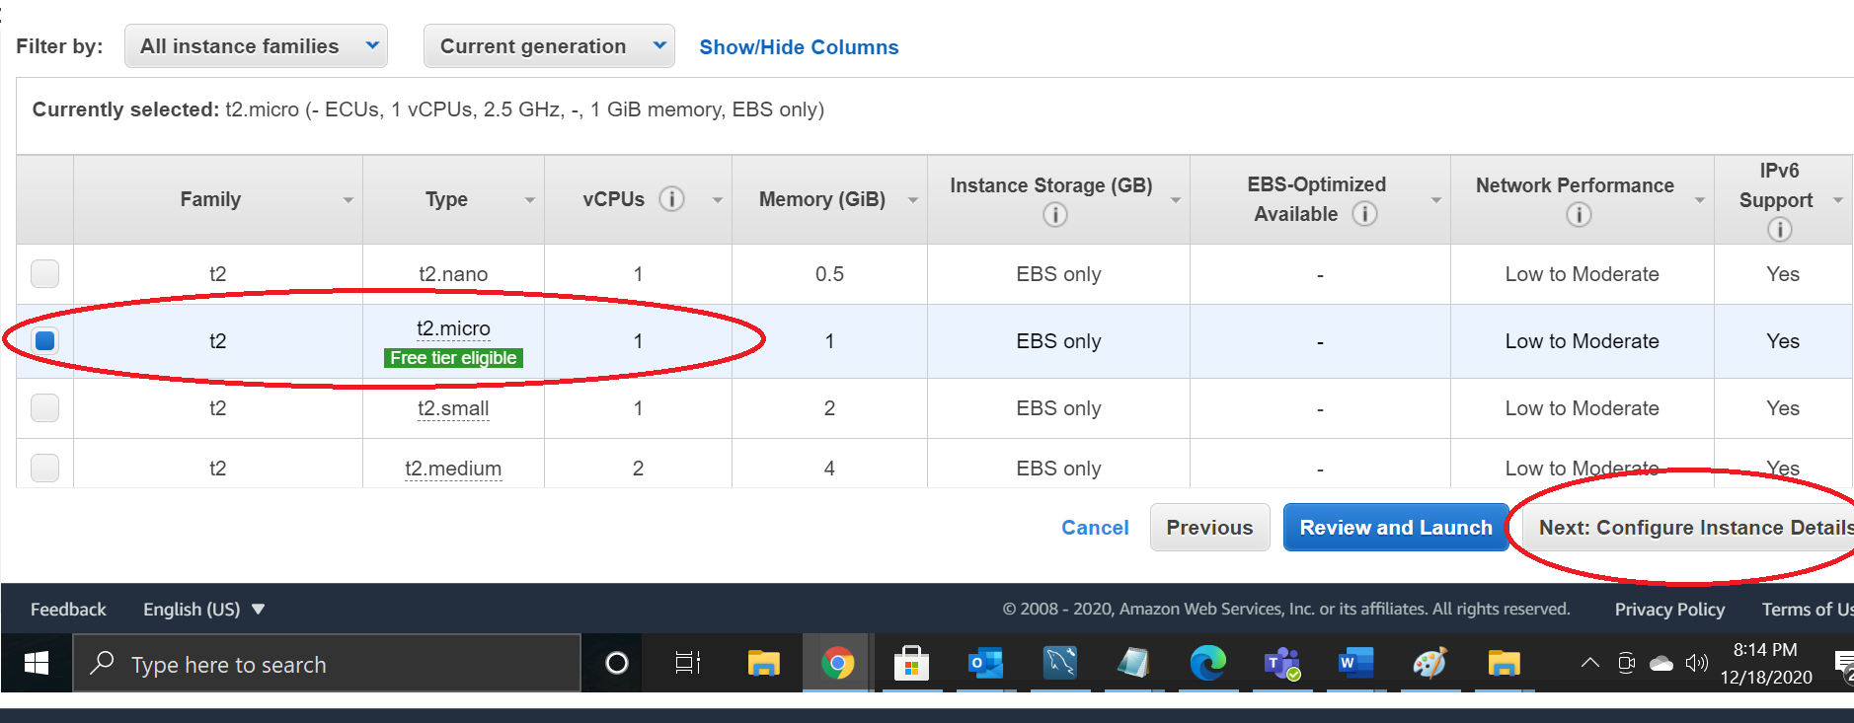

* Leave to the default settings

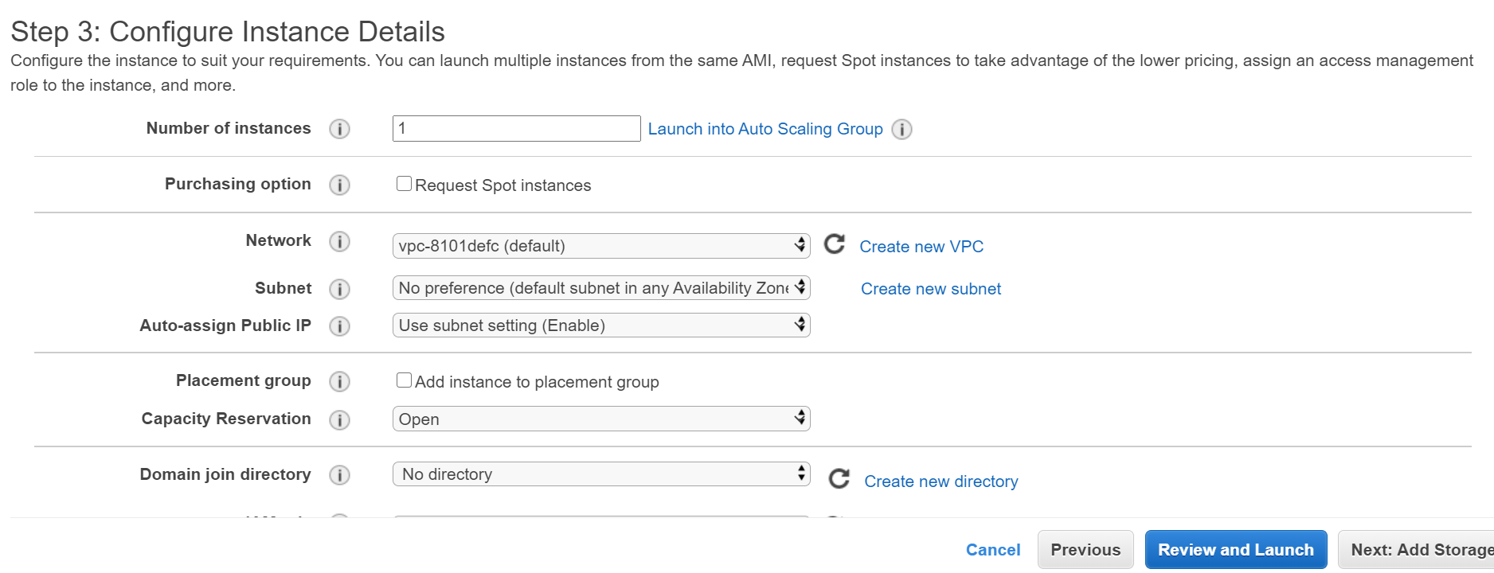

Create a MongoDB 27017 port and open it

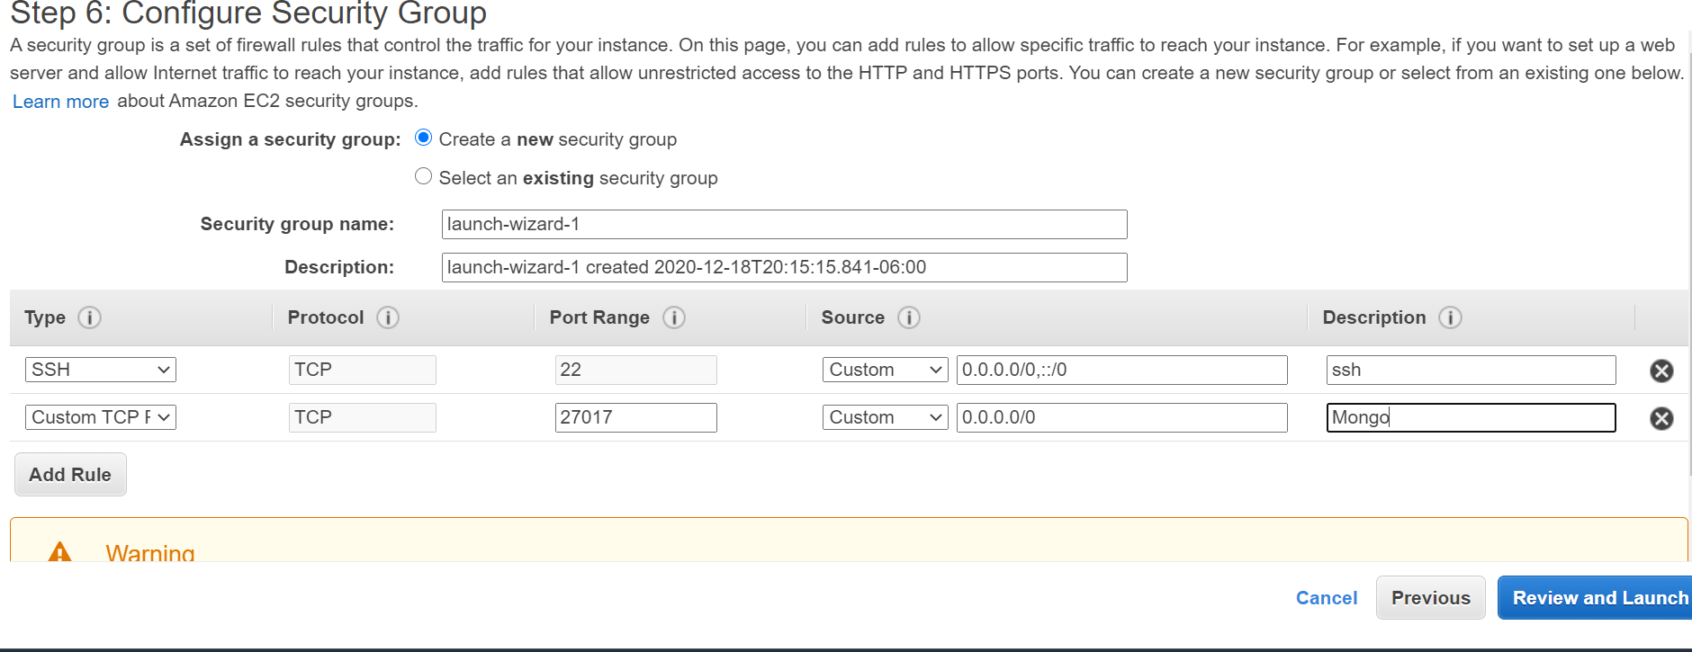

* Launch the configuration

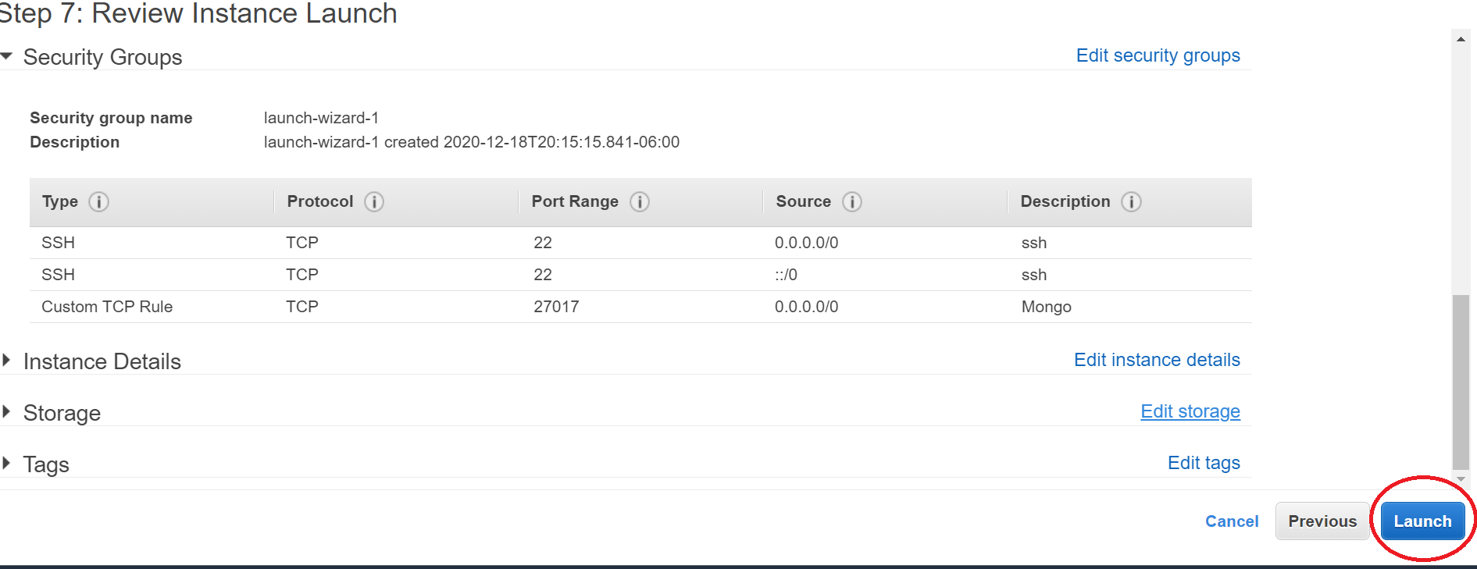

* Connect to the AWS EC2 instance using the ip address

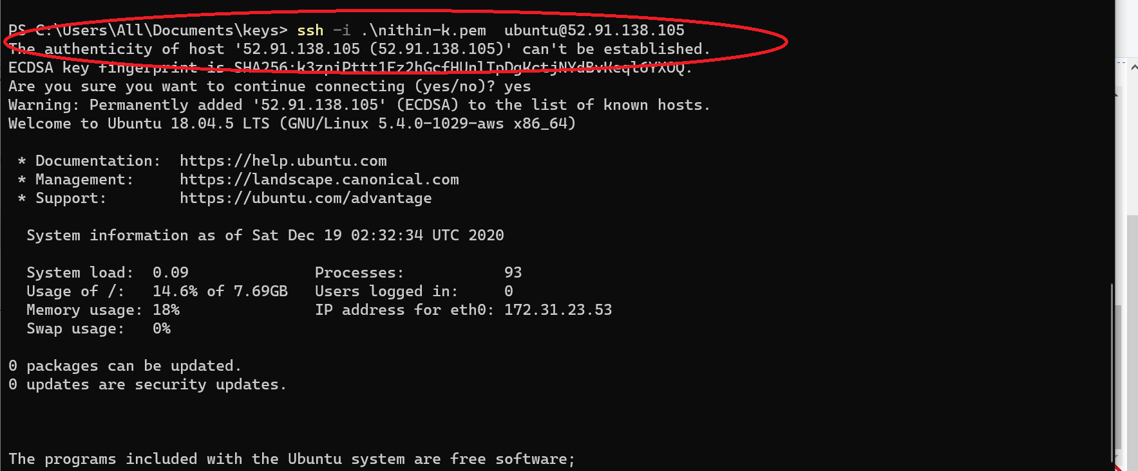

### **Install the MongoDb packages**

Login to your EC2 then type the commands:

Import the public key used for accessing package management system

$wget -qO - https://www.mongodb.org/static/pgp/server-4.2.asc | sudo apt-key add -

Create a list file for mongoDB

$echo "deb [ arch=amd64 ] https://repo.mongodb.org/apt/ubuntu bionic/mongodb-org/4.2 multiverse" | sudo tee /etc/apt/sources.list.d/mongodb-org-4.2.list

$sudo apt-get update

$sudo apt-get install -y mongodb-org

Start the mongodb:

$sudo service mongod start

Verify the mongod service

$sudo service mongod status

### **Enable remote access to the mongoDB server running on EC2**

Follow the instruction in the below link:

Create the remote users, but first create admin -

Enter the mongo shell on EC2

$sudo mongo

Select admin DB

>use admin

Change the admin password to something else

Create the “admin” user (you can call it whatever you want). the exit command is used to close the shell

> db.createUser({ user: "admin", pwd: "adminpassword", roles: [{ role: "userAdminAnyDatabase", db: "admin" }] })

> db.auth("admin", "adminpassword")

> exit

We are now going to enable authentication on the MongoDB instance, by modifying the mongod.conf file. If you’re on Linux:

$sudo vim /etc/mongod.conf

Note: to enter edit/insert mode in vim, press 'i'. To save/exit, type ':x':

Add these lines at the bottom of the YAML config file:

security:

authorization: enabled

This will enable authentication on your database instance.

Important -- external access

By default MongoDB instance is listening on the local loopback interface only. This means that the DBMS will be accepting connections to the databases only when they come from the host itself.

So, open mongod.conf in edit mode again, as we’re going to check out the net.bindIp option. That option tells the mongod process on which interfaces it should listen.

net:

bindIp: 0.0.0.0

With this configuration, MongoDB will be listening on 0.0.0.0 (“all the networks”). It means that mongod will listen on all the interfaces configured on your system. Pay attention that in this way you are likely going to allow everyone on the Internet to access your database (as far as they have the credentials, of course, so pay particular attention to poor passwords).

Restart

Now restart the mongod service (Ubuntu syntax) for the changes to take effect

$sudo service mongod restart

You can check if the service is up with:

$sudo service mongod status

To create a external user login to mongo db account such as 'ubuntu'- Now login to mongo shell and select admin db and authenticate

$sudo mongo

>use admin

>db.auth("admin", "adminpassword")

now create lahman database in mongo

>use lahman;

create remote user name - 'ubuntu' and a passowrd who can use lahman db (this is generally a good idea. You restrict access for people)

>db.createUser({ user: "ubuntu", pwd: "yourpassword", roles: [{ role: "dbOwner", db: "lahman" }] })

Check that everything went fine by trying to authenticate, with the db.auth(user, pwd) function.

>db.auth("ubuntu", "yourpassword")

Note - keep your username and password private. Very important. This is what you will use to connect to the database.

Refer to the link if you get stuck: <https://medium.com/@matteocontrini/how-to-setup-auth-in-mongodb-3-0-properly-86b60aeef7e8>

### **Loading the MongoDB with Lahman database**

Download the lahman database to your windows or Mac Host from <http://www.seanlahman.com/files/database/> Use the lahman_sql_2012 comma delimited version (CSV) files.

$mkdir rawfiles

$cd rawfiles

$wget http://www.seanlahman.com/files/database/lahman2012-csv.zip

$unzip lahman2012-csv.zip

Note - you might be asked to install unzip - follow prompts

if everything went well - it will look like following

~/rawfiles$ ls

AllstarFull.csv AwardsPlayers.csv Batting.csv FieldingOF.csv Managers.csv Pitching.csv Salaries.csv SeriesPost.csv TeamsHalf.csv

Appearances.csv AwardsShareManagers.csv BattingPost.csv FieldingPost.csv ManagersHalf.csv PitchingPost.csv Schools.csv Teams.csv

AwardsManagers.csv AwardsSharePlayers.csv Fielding.csv HallOfFame.csv Master.csv 'readme 2012.txt' SchoolsPlayers.csv TeamsFranchises.csv

Then import the csv files into mongoDB using the below command. Do this for all the .csv files

$mongoimport -d <dbname> -c <collection_name>t --type csv --file <input.csv> --headerline.

Below are the import commands for all csv files to import into the mongodb - you need to update the username and password to what you set up -- see the instructions above

Using an online "find-and-replace" tool to change the "username" and "yourpassword" fields for all below queries will make this process faster.

$mongoimport -d lahman -c AllstarFull --type csv --file AllstarFull.csv --headerline --username "ubuntu" --password "yourpassword"

$mongoimport -d lahman -c AwardsSharePlayers --type csv --file AwardsSharePlayers.csv --headerline --username "ubuntu" --password "yourpassword"

$mongoimport -d lahman -c Appearances --type csv --file Appearances.csv --headerline --username "ubuntu" --password "yourpassword"

$mongoimport -d lahman -c AwardsManagers --type csv --file AwardsManagers.csv --headerline --username "ubuntu" --password "yourpassword"

$mongoimport -d lahman -c AwardsShareManagers --type csv --file AwardsShareManagers.csv --headerline --username "ubuntu" --password "yourpassword"

$mongoimport -d lahman -c AwardsPlayers --type csv --file AwardsPlayers.csv --headerline --username "ubuntu" --password "yourpassword"

$mongoimport -d lahman -c Batting --type csv --file Batting.csv --headerline --username "ubuntu" --password "yourpassword"

$ls

$mongoimport -d lahman -c Fielding --type csv --file Fielding.csv --headerline --username "ubuntu" --password "yourpassword"

$mongoimport -d lahman -c FieldingOF --type csv --file FieldingOF.csv --headerline --username "ubuntu" --password "yourpassword"

$mongoimport -d lahman -c FieldingPost --type csv --file FieldingPost.csv --headerline --username "ubuntu" --password "yourpassword"

$mongoimport -d lahman -c HallOfFame --type csv --file HallOfFame.csv --headerline --username "ubuntu" --password "yourpassword"

$mongoimport -d lahman -c Managers --type csv --file Managers.csv --headerline --username "ubuntu" --password "yourpassword"

$mongoimport -d lahman -c ManagersHalf --type csv --file ManagersHalf.csv --headerline --username "ubuntu" --password "yourpassword"

$mongoimport -d lahman -c Master --type csv --file Master.csv --headerline --username "ubuntu" --password "yourpassword"

$mongoimport -d lahman -c Pitching --type csv --file Pitching.csv --headerline --username "ubuntu" --password "yourpassword"

$mongoimport -d lahman -c PitchingPost --type csv --file PitchingPost.csv --headerline --username "ubuntu" --password "yourpassword"

$mongoimport -d lahman -c Salaries --type csv --file Salaries.csv --headerline --username "ubuntu" --password "yourpassword"

$mongoimport -d lahman -c Schools --type csv --file Schools.csv --headerline --username "ubuntu" --password "yourpassword"

$mongoimport -d lahman -c SchoolsPlayers --type csv --file SchoolsPlayers.csv --headerline --username "ubuntu" --password "yourpassword"

$mongoimport -d lahman -c SeriesPost --type csv --file SeriesPost.csv --headerline --username "ubuntu" --password "yourpassword"

$mongoimport -d lahman -c Teams --type csv --file Teams.csv --headerline --username "ubuntu" --password "yourpassword"

$mongoimport -d lahman -c TeamsFranchises --type csv --file TeamsFranchises.csv --headerline --username "ubuntu" --password "yourpassword"

$mongoimport -d lahman -c TeamsHalf --type csv --file TeamsHalf.csv --headerline --username "ubuntu" --password "yourpassword"

you can use a cool shell command to import all

$for file in `ls *.csv`; do mongoimport -d lahman -c `basename $file .csv` --type csv $file --headerline --username "ubuntu" --password "yourpassword";done

### **Check connection using MongoDB compass:**

Download the mongoDB compass <https://www.mongodb.com/try/download/compass>

And test the connection and basic queries

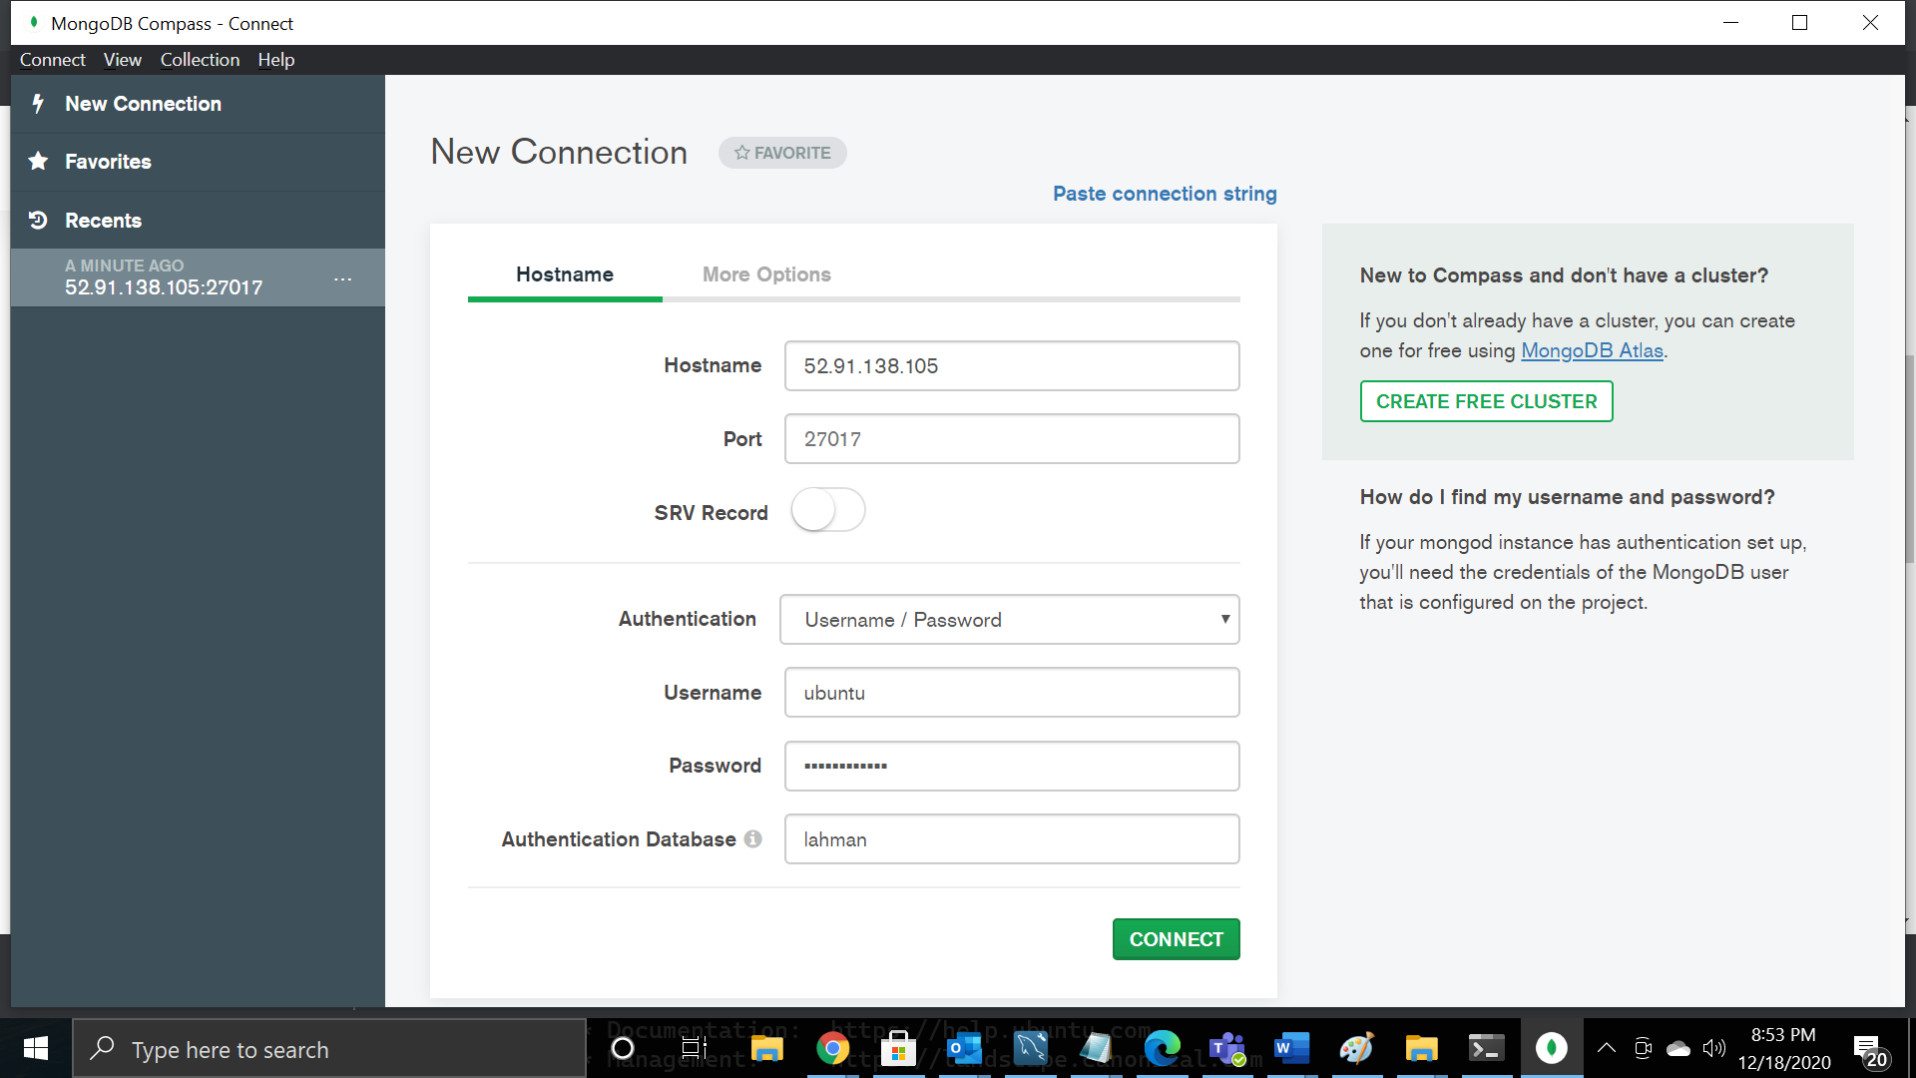

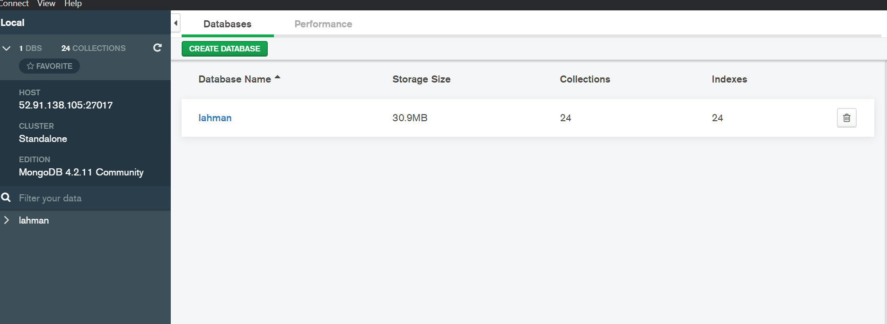

* Remember to shutoff the EC2 instance when you are not using it.

### 